**DAILY ONLINE ACTIVITIES SUMMARY**

|  |  |  |  |  |  |  |
| --- | --- | --- | --- | --- | --- | --- |
| **Date:** | | **03/06/2020** | | | | |
| **Name of the Faculty** | | **Shilpa** | | | | |
| **No. of Students Allotted for monitoring** | | | | **19** | | |
| **Progress** | | | | **Good** | | |
| **Whether collected report from all the allotted students** | | | | **15 submitted.** | | |
| **Online Test Summary** | | | | | | |
| **Subject** | **Object Oriented Concepts** | | | | | |
| **Semester** | **IV** | | | **Duration** | **45 min** | |
| **No. of students Taken** | | | **95** | **Passing %** | **66.3** | |
| **Certification Course Summary** | | | | | | |
| **Course** | | 1. **Webinar on Python Programming** 2. **Role of Science and Technology in Nation Building** | | | | |
| **Certificate Provider** | | 1. **SJBIT** 2. **BIT** | | **Duration** | | **2 Hour each** |
| **Coding Challenges** | | | | | | |
| **Problem Statement: - Write a Java program to find Last Digit of a^b (a to the power b) for Large Numbers** | | | | | | |
| **Status: - 32** | | | | | | |
| **Uploaded the report in Github** | | | | **Yes** | | |
| **If yes Repository name** | | | | <https://github.com/orgs/alvas-education-foundation/teams/2nd-year> | | |
| **Uploaded the report in slack** | | | | **Yes** | | |

Coding Challenge

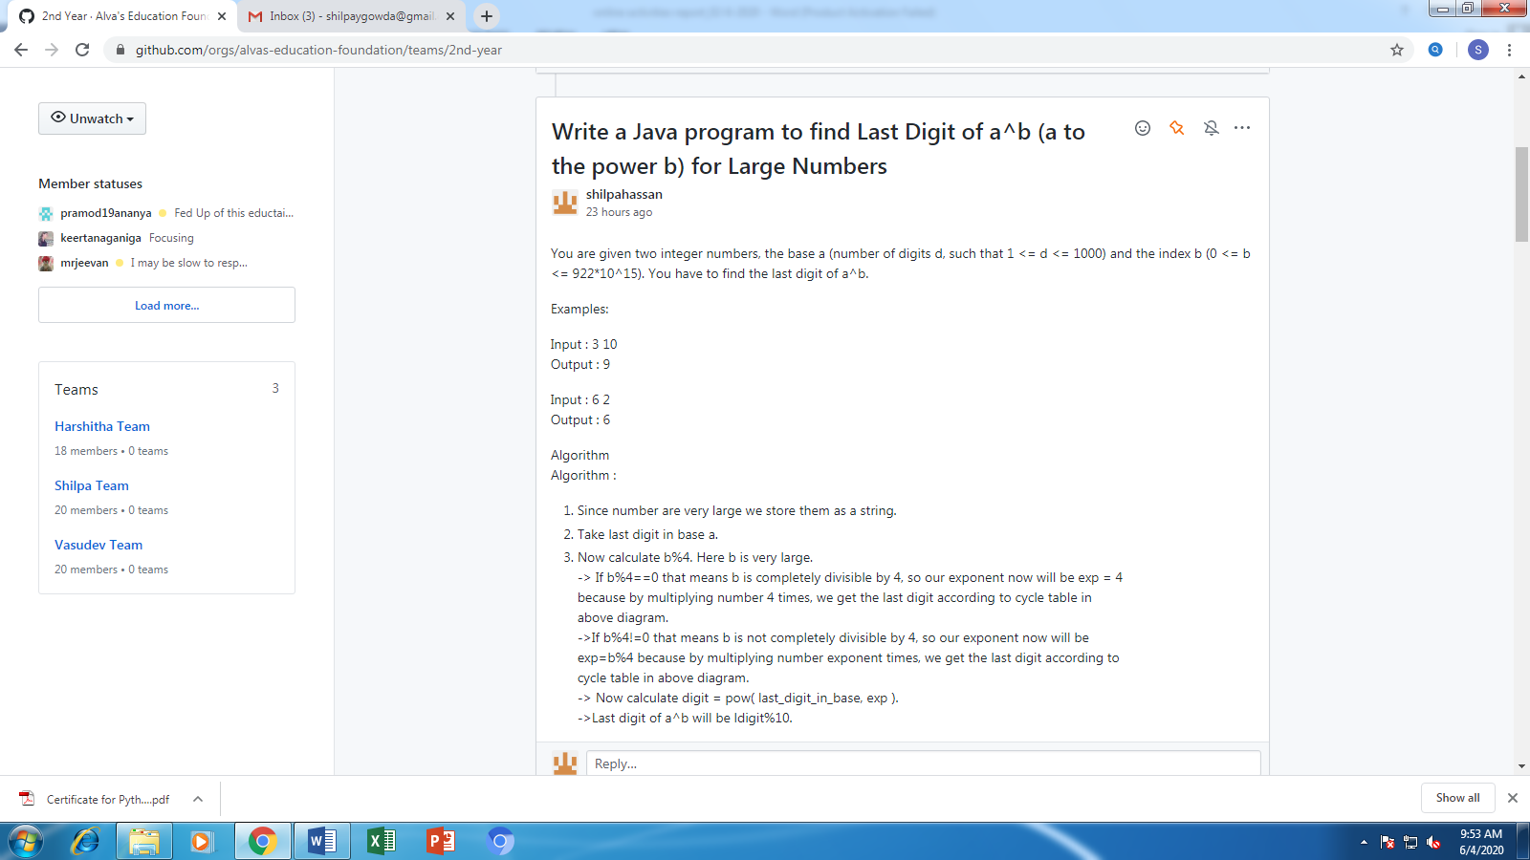

**Certification/webinar Course Summary**

**Students Report:**

